Sprint 1 Plan

Version 0.0.0. Genesis, T.E.A.M.

Goal:

* User within the campus can know the nearest bus stop list all routes that go through the bus stop

Task Listing and roles (by user story):

* **I am a student, and I want to see what routes I can take from my bus stop**
  + Task: Build the DAO, access routes information from database, push them to the front end (2 hours)(Riwen)
* **I am a user, and I want to see the bus schedules for each bus (provide pdfs)**
  + Task: Set up local database (file in project folder) and manually input Santa Cruz Metro bus schedules for Bus Lines 19, 20, 10, 15, and 16 (4 hours) (Calvin)
  + Task: Create data service to grab data from MySQL and pass to Controller (1 hour) (Riwen)
  + Task: Create Bus Schedule View, using Bootstrap Card layout (1 hour) (Josh)
  + Task: Use JavaScript (or jquery) to color cards according to their bus line (30 min) (Josh)
* **I am a user, and I want to be able to log into the application**
  + Task: Link Bootstrap and Jquery CDNs to web application (10 min) (Josh)
  + Task: Create Index view with location Input (1 hour)
  + Task: Create dropdown list of residential college locations to use for location input (1 hour) (Josh)
  + Task: Create Home Controller (1 hour) (Karl)
  + Task: Create Navigation Tabs (1 hour) (Karl)
* **I am a student, and I want to know the direction the bus is heading**
  + Task: Link bus routes from Santa Cruz Bus schedules corresponding to selected busses. (1 hour)(Cyrus)
  + Task: Create options to see busses going either southbound or northbound (.5 hour)

Initial Burnup Chart:

Sprint 1 Slug’s Bus Schedule

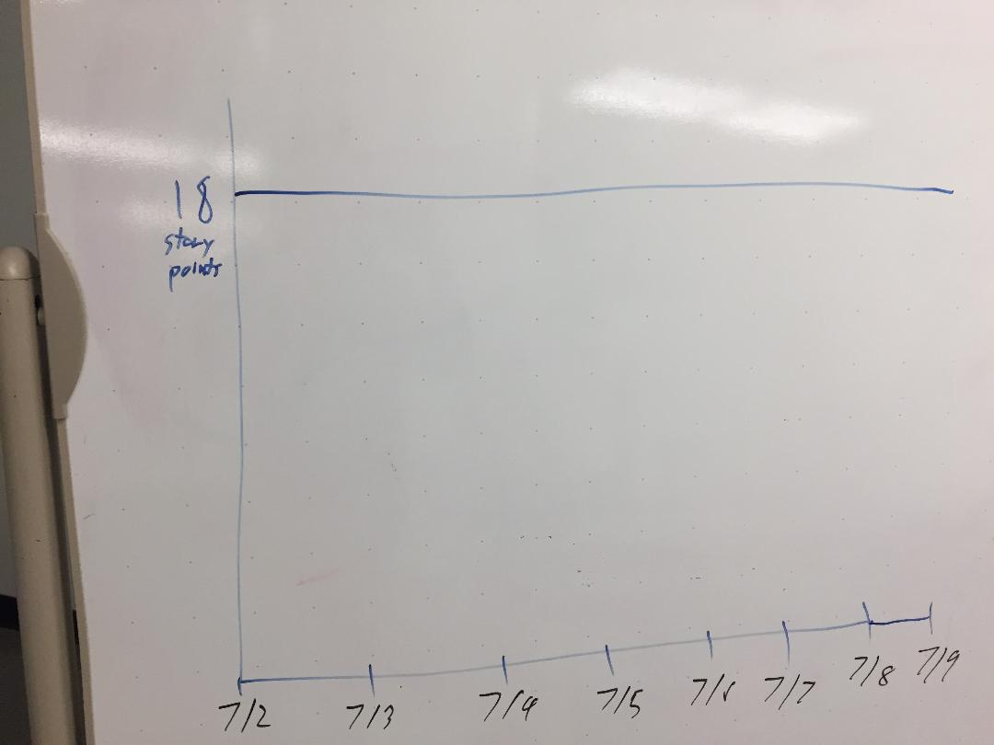

Initial Scrum Board:

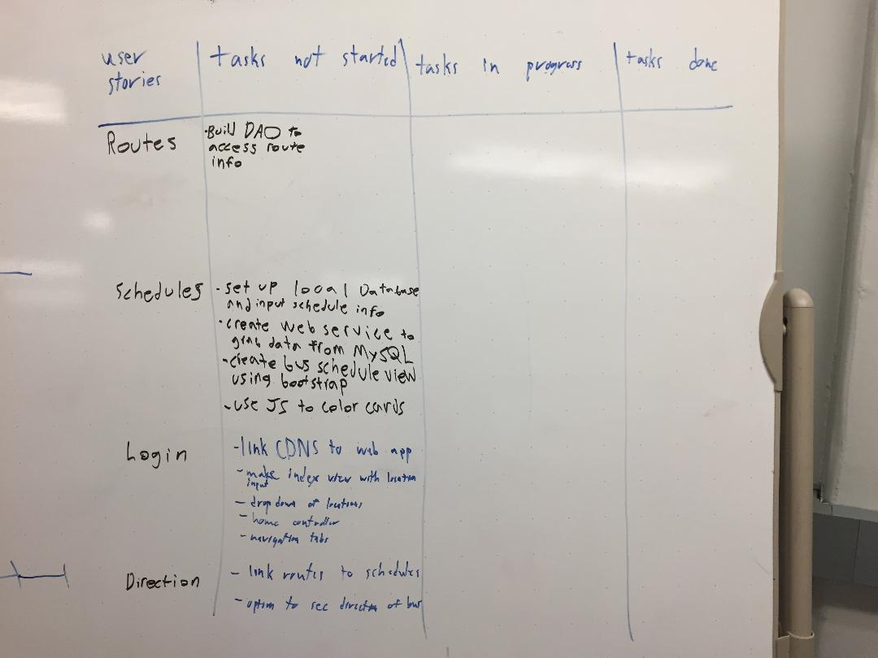

Scrum Times:

1. Monday (5:30 to 6:00) with TA
2. Tuesday (12:30 to 1:00)
3. Thursday (5:30 to 6:15) with TA